PS5 Discussion

Examples of sentences tagged correctly:

My/PRO attorney/N is/V named/VN Daniel/NP

My/PRO cat/N ran/VD around/P the/DET blue/ADJ house/N

Examples of sentences tagged incorrectly:

Buffalo buffalo buffalo buffalo buffalo buffalo buffalo buffalo

For this sentence, each buffalo was tagged with NP. In the sentence, buffalo can serve as a proper noun, a noun, and a verb. Our algorithm does not distinguish perfectly between words that have multiple meanings.

Adding the unseen-word penalty adds extra weight on the observations rather than relying on the transitions between states. When changing from an unseen-word penalty of -10 to -100, the performance of the algorithm does not change. However, when we changed the unseen-word penalty to -1, the percent error of our tags was 92%, since observations were not taken into account as heavily during training.

Testing on hard coded graphs

Example test created using in-class example of hot and cold temperatures as states with ice cream and soup as observations

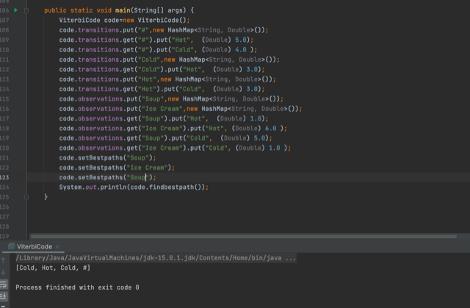

The transition between hot and cold states were hard coded with scores of 5 and 4, respectively.

The observations of soup and ice cream were weighted so that soup was more likely to be observed in the cold state and ice cream was more likely to be observed in the hot state. The output of the program showed that the most likely state for soup correctly returned as cold and hot for ice cream.

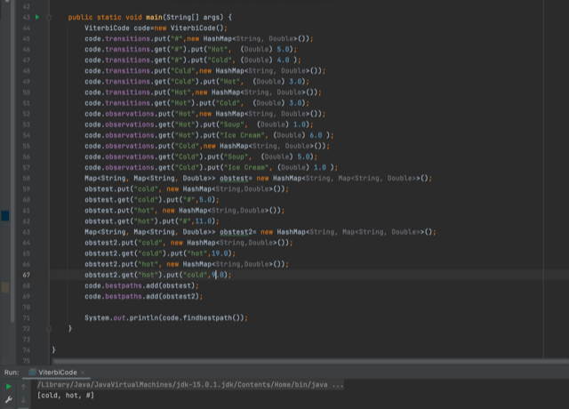

Testing whether algorithm correctly chooses the state with the higher score as the previous state.

Output shows that scores were correctly evaluated for both previous states.

Testing and training on simple tests:

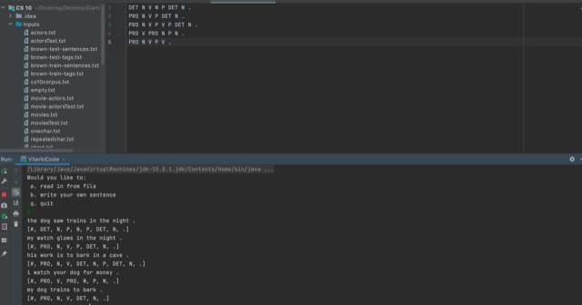

The output shows that each sentence was tagged correctly except two words from the last sentence.

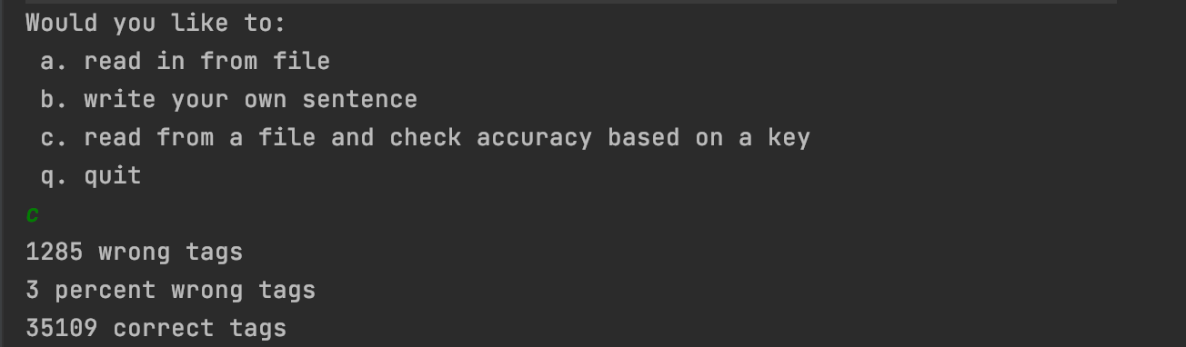

Output from accuracy testing of Brown test files. Our algorithm matches the number of expected incorrect tags and number of expected correct tags.